Advanced Database
Homework (1)
- Consider the B+ tree index of order n = 5 shown in figure below:
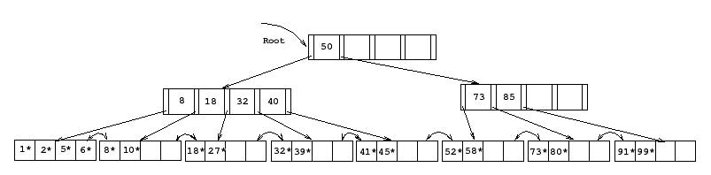

  - Show the tree that would result from inserting a data entry with key 9 into this tree.

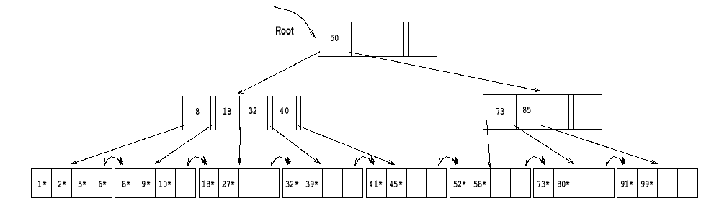
  - Show the B+ tree that would result from inserting a data entry with key 3 into the original tree.

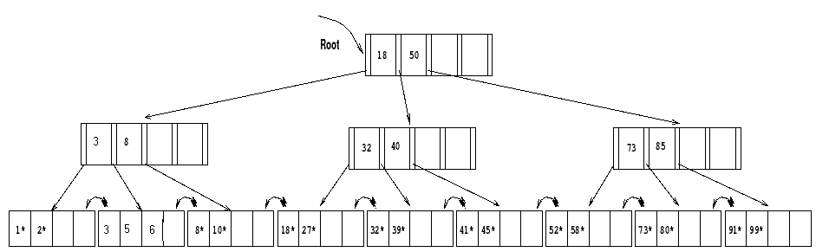
  - Show the B+ tree that would result from deleting the data entry with key 8 from the original tree, assuming that the left sibling is checked for possible redistribution.
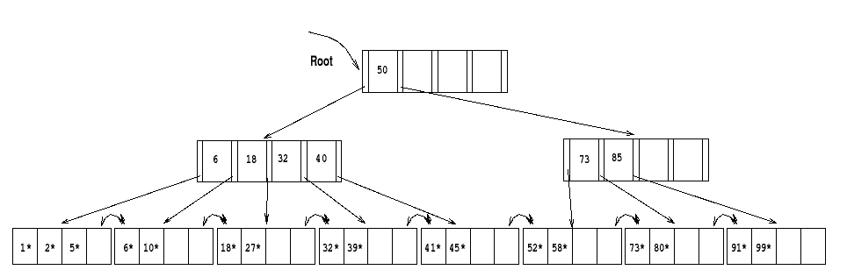
  - Show the B+ tree that would result from starting with the original tree, inserting a data entry with key 46 and then deleting the data entry with key 52, assuming that the right sibling is checked for possible redistribution.

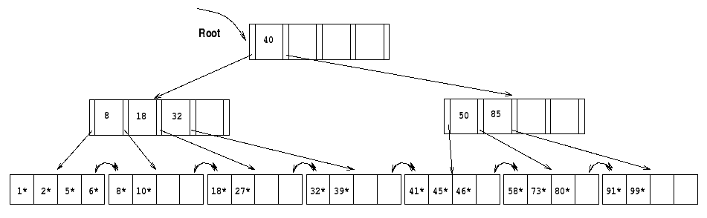
  - Show the B+ tree that would result from deleting the data entry with key 91 from the original tree.
